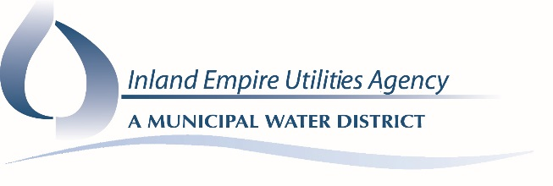
Special Regional Technical Committee Workshop

AGENDA
August 22, 2018
1:00 p.m.

Location
Inland Empire Utilities Agency
Anza Conference Room – Building B
6075 Kimball Avenue
Chino, CA 91708

Call to Order and Roll Call

Additions/Changes to the Agenda

- Informational Items
- Regional Contract Negotiations

- Adjournment

DECLARATION OF POSTING
I, Laura Mantilla, Executive Assistant of the Inland Empire Utilities Agency, A Municipal Water District, hereby certify that a copy of this agenda has been posted to the IEUA Website at www.ieua.org and posted in the foyer at the Agency's main office at 6075 Kimball Avenue, Building A, Chino, CA, on Monday, August 20, 2018.

Laura Mantilla

